NOTICE
Dated : 03.04.2023

A meeting of the IQAC of the college will be held on 5th April 2023 at 1.15 pm in the chamber of the Principal to discuss the following agenda-

- Preparation for NAAC.
- Miscellaneous

All the members of the committee are requested to attend the meeting.

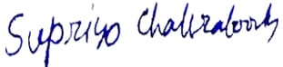 Principal 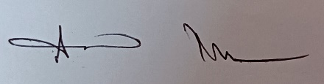
Kulti College, Kulti
IQAC Coordinator
Kulti College, Kulti

